.

Functional Design Document
FDD_Document Management System
Version 2.1

7/30/2010

Table of Contents
Table of Contents 2
Table of Figures 3
List of Tables 5
1. Document Authorization 7
2. Reviewers 8
3. Icons List 9
4. Introduction 11
4.1 Purpose of this document 11
4.2 Management Summary 11
4.3 Inputs for the Document 11
4.4 Scope of this Document 11
4.5 Out of Scope 11
4.6 Assumptions 11
5. References 12
5.1 Document References 12
5.2 Internal & External Contacts 12
6. Overview of this document 12
7. Process Flow 12
8. Users 16
9. Functional Requirements – Use Cases 17
9.1 FR_DMS_01: Access ‘Documents’ 17
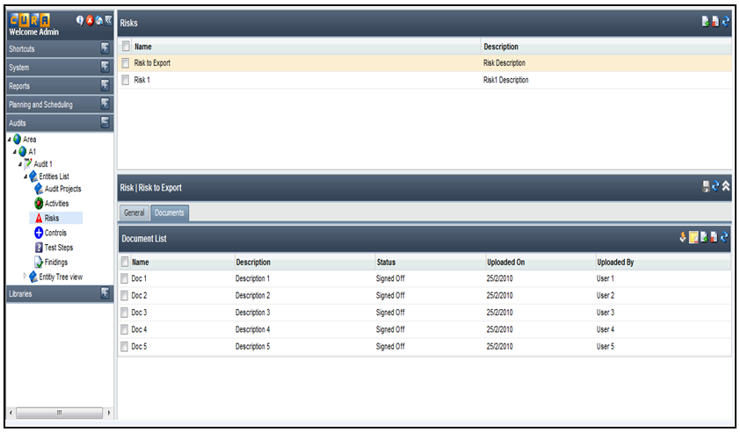 20
9.2 FR_DMS_02: Create New Document Containers 21
9.3 FR_DMS_03: Add New Version of a Document / Check in 26
9.4 FR_DMS_04: Linking / Associating Documents and Entity Instances 30
9.5 FR_DMS_05: Trigger a Task 35
9.6 FR_DMS_06: Manage Document Status 39
9.7 FR_DMS_07: View Document Details 43
9.8 FR_DMS_08: View Version History 47
9.9 FR_DMS_09: Download Document 50
9.10 FR_DMS_10: Check Out Documents 54
9.11 FR_DMS_11: Delete a Document or a Document Version 59
9.12 FR_DMS_12: Remove Association between Documents & Entity Instances 64
9.13 FR_DMS_13: Apply Permissions on Documents 68

Table of Figures
Figure 1 - Document Management through 'Documents' section under an Audit 12
Figure 2 - Document Management through 'Documents' node under an Entity Instance 13
Figure 3 - Document Management through 'Documents' tab under an Entity Instance 14
Figure 4 - Accessing Documents through the 'Documents' section under an Audit 18
Figure 5 - Accessing Documents through 'Documents' node under an Entity Instance 18
Figure 6 - Accessing Documents through 'Documents' tab under an Entity Instance 19
Figure 7 – Uploading Documents from the ‘Documents’ section under an Audit 23
Figure 8 - Entering / Changing the name and description for the uploaded documents 23
Figure 9 – Uploading Documents through 'Documents' node under an Entity instance 24
Figure 10 - Uploading Documents through 'Documents' tab under an Entity Instance 24
Figure 11 - Check in Document through 'Documents' section under an Audit 28
Figure 12 – Linking Entity Instances to a Document 32
Figure 13 – Linking Documents to an Entity Instance 33
Figure 14 - Clicking on 'Add Task' icon to trigger a task 36
Figure 15 - Entering Details in the 'Add Task' window 37
Figure 16 - Managing Document Status 41
Figure 17 - Viewing Document Details - 'Document Details' tab 44
Figure 18 - Viewing Document Details - 'Version History’ tab 44
Figure 19 - Viewing Document Details - 'Link To' tab 45
Figure 20 - Viewing Document Details - 'Tasks' tab 45
Figure 21 - Viewing Version History of a document 48
Figure 22 - Downloading the active versions of documents 52
Figure 23 - Downloading previous version of the document 52
Figure 24 - Checking Out Documents 56
Figure 25 - Displaying Checked Out Document with a Lock Icon 56
Figure 26 - Overriding a Check Out 57
Figure 27 - Deleting a document 61
Figure 28 - User with 'Manage All' permissions deleting the previous versions of a document 62
Figure 29 - Removing association between a document and the linked Entity Instances 66
Figure 30 - Removing association between an Entity Instance and linked Documents 66
Figure 31 - Applying Document Management Permissions 69

List of Tables
Table 1 – Version Control Chart 5
Table 2 - Document Authorization 6
Table 3 - Reviewers List 7
Table 4 – Glossary 7
Table 5 - Icons List 9
Table 6 - Document References 11
Table 7 - Contacts List 11

Version Control
Version No. | Created on | Status | Changes
1.0 | 25th May 2010 | Draft | Initial Draft
1.1 | 8th June 2010 | Draft | John’s comments incorporated
1.2 | 11th June 2010 | Draft | John’s comments incorporated
1.3 | 22nd June 2010 | Draft | John’s comments incorporated
1.4 | 24th June 2010 | Draft | John’s comments incorporated and wireframes updated
1.5 | 28th June 2010 | Draft | John’s comments incorporated and wireframes updated
1.6 | 1st July 2010 | Draft | Wireframes updated as per John’s comments
1.7 | 5th July 2010 | Draft | Wireframes updated as per John’s comments
1.8 | 21st July 2010 | Draft | New functionality of bulk upload added
1.9 | 23rd July 2010 | Draft | Changes made to the wireframes for the Bulk Upload Feature
2.0 | 28th July 2010 | Draft | Review comments from Avi incorporated
2.1 | 30th July 2010 | Draft | Browse button replaced with icon
2.1 | 6th August 2010 | Signed Off | Signed Off
Table 1 – Version Control Chart

Document Authorization
Version No. | Document Preparation |  | Document Verification |  | Document Approval
Version No. | Prepared By | Date | Verified By | Date | Approved By | Date
1.0 | Tony | 25th May 2010 | John Wakeford | 1st June 2010 | NA | NA
1.1 | Tony | 8th June 2010 | John Wakeford | 9th June 2010 | NA | NA
1.2 | Tony | 11th June 2010 | John Wakeford | 14th June 2010 | NA | NA
1.3 | Tony | 22nd June 2010 | John Wakeford | 23rd June 2010 | NA | NA
1.4 | Tony | 24th June 2010 | John Wakeford | 25th June 2010 | NA | NA
1.5 | Tony | 28th June 2010 | John Wakeford | 30th June 2010 | NA | NA
1.6 | Tony | 1st July 2010 | John Wakeford | 2nd July 2010 | NA | NA
1.7 | Tony | 5th July 2010 | John Wakeford | 19th July 2010 | NA | NA
1.8 | Tony | 21st July 2010 | John Wakeford | 23rd July 2010 | NA | NA
1.9 | Tony | 23rd July 2010 | Avi Eyal | 26th July 2010 | NA | NA
2.0 | Tony | 28th July 2010 | John Wakeford | 29th July 2010 | NA | NA
2.1 | Tony | 30th July 2010 | John Wakeford & Avi Eyal | 6th August 2010 | John Wakeford & Avi Eyal | 6th August 2010
Table 2 - Document Authorization

Reviewers
Mail Id | Position
JohnP@MAGNUS.com | Product Manager
AviS@MAGNUS.com | Chief Technical Officer
Table 3 - Reviewers List
Glossary of Terms
Term | Meaning in document
IA | Internal Audit
Table 4 – Glossary

Icons List
This section contains a list of all the icons used in the screenshots in this specification and the expected actions that are associated therewith. Please note that if an action cannot as yet be performed the icon should be greyed out and should only appear active (in colour) if the action can be performed. Most of these icons are to function as implemented in Magnus Web Assessor GWT.

Icon | Label
 | Close
 | Add Item
 | Delete item
 | Filter
 | Add to Bookmarks
 | Refresh/ Also a status indicator to indicate that a notification message is in a retry state
 | Save
 | Schedule
 | Bookmarks grouping node
 | Manage Bookmarks
 | My Shortcuts
 | About
 | System information
 | Profile
 | Notification Event Group
 | Event
 | Template Group
 | Template
 | Edit template
 | Methodology
 | Copy
 | Move Left
 | Move Right
 | Move Selected Conditions Up
 | Move Selected Conditions Down
 | Add New Condition/ Resend a message
 | Delete Selected Conditions/ Cancel a message. Also a Status icon to indicate that a notification message has been cancelled
 | Indicates that a notification message has been created but not yet sent
 | Indicates that a notification message has failed to send
 | Upload a document
 | Add new version or Check in a document
 | Delete Document
 | Link – Entity Instances to Document or Documents to an Entity Instance
 | Remove Association
 | Download Document
 | Check Out Document
 | Document Checked Out
 | Add Task
 | Edit Task
 | Delete Task
 | Save Disabled
 | Unlock / Override Check Out
 | Document Signed Off
Table 5 - Icons List

Introduction

Purpose of this document
The purpose of this document is to detail the requirements for designing the Document Management System for Internal Audit. This document can be used by Product Architects, Software Engineers, Testing Engineers and Product Consultants.

Management Summary
Currently, the Internal Audit module does not have Document Management System in place. While Audits are being performed, there will be loads of documents in form of evidences, findings and vouchers etc that need to be attached. It would be difficult to keep a track of these documents without an organized mechanism. Hence there is a need of Document Management System.

Inputs for the Document
This document has been prepared based on the following documents and discussions with the Product Manager, John Wakeford.
Business Requirement for Document Management (v1.0.3) (12-5-2010)
(See Document References #2.1)

Scope of this Document
The current scope for Document Management System, as outlined in this document is to manage the upload of documents under a particular entity, link it to various entities, maintain various versions of the document and download them when required.

Out of Scope
The functionality of creating documents and editing them in the application has been excluded from the current scope of Document Management System for Internal Audit.

Assumptions
The requirements have been detailed with an assumption that the Document Management under Libraries is handled exactly the same way as it is handled under Audits.

References

Document References
Title | Author | Document Attachment
Business Requirements for Document Management System (v1.0.3) (2010-05-12) | John Wakeford
Adhoc Tasking in Internal Audit Functional Specification (v1.0) (2010-07-02) | Sirisha
Permission Management Functional Specs (v2.2.9) (2010-02-05) - SIGNED OFF | Rene
Table 6 - Document References

Internal & External Contacts
Name | Role in the Functional Design | Email
John | Product Manager | JohnP@MAGNUS.com
Mike | Director of Engineering | MikeT@Magnus.com
Rene | Delivery Manager | ReneS@Magnus.com
Tony | Business Analyst | TonyA@Magnus.com
Table 7 - Contacts List

Overview of this document
The process flows being followed for Document Management in IA have been depicted in Section 7. Section 8 talks of the users of the system. The functional requirements have been detailed in section 9 in form of Use Cases.

Process Flow
The following are the process flows being followed for Document Management in IA.
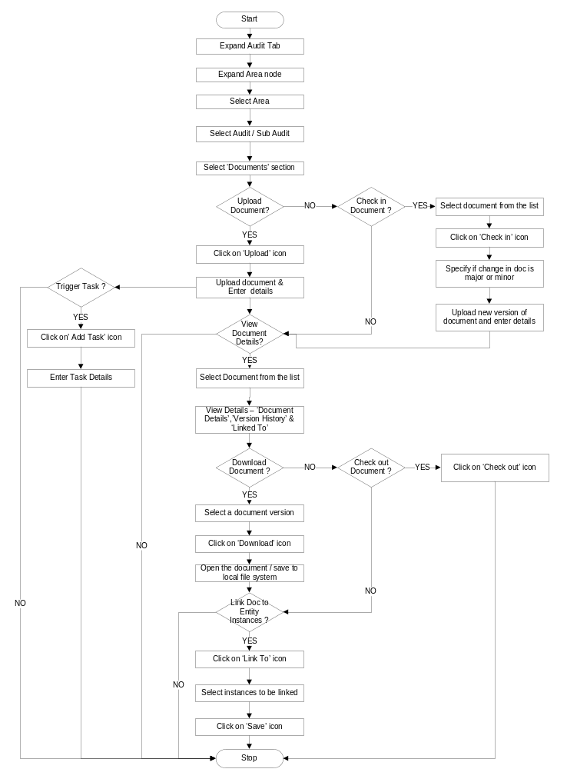
Figure 1 - Document Management through 'Documents' section under an Audit
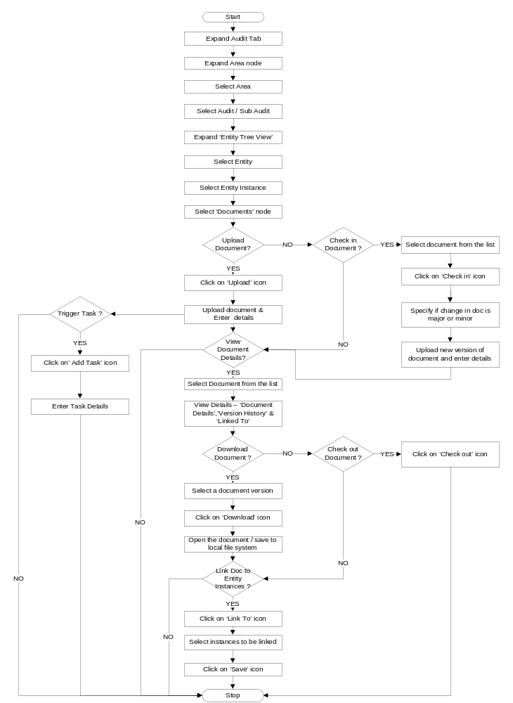
Figure 2 - Document Management through 'Documents' node under an Entity Instance
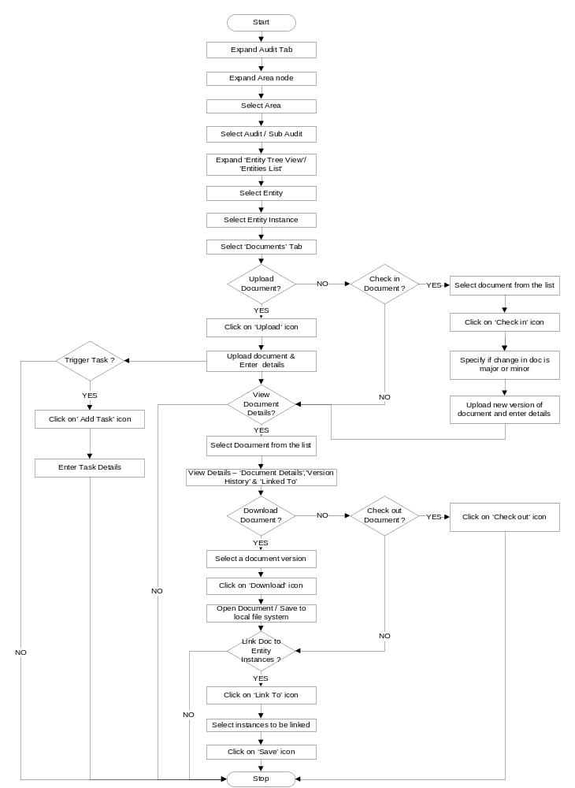
Figure 3 - Document Management through 'Documents' tab under an Entity Instance

Users
Document Management System could be used by the following users:

Document User: is the user who can view documents, upload documents, download them as required and link them to various entity instances based on the permissions provided.

Functional Requirements – Use Cases

FR_DMS_01: Access ‘Documents’

Use Case Detail
Name | Access ‘Documents’
Summary | Documents used in an Audit can be accessed from 3 places  - ‘Documents’ section available under an Audit which displays the list of all the documents under that particular audit.  - ‘Documents’ node under an Entity instance which can be accessed through the ‘Entity Tree View’  - ‘Documents’ tab under an Entity instance which can be accessed through the ‘Entity Tree View’ or ‘Entities List’  However, the ‘Documents’ node under an Entity instance would be visible if the entity has been configured (in Meth Builder) to have documents and if the instance has documents attached to it.
Actors | Document User
Preconditions | - The User is logged on to Internal Audit  - The User has access to the chosen Area  - The User has access to the chosen Audit / Sub Audit
Triggers | - Expanding the chosen Audit  - Expanding the ‘Entity Tree View’  - Expanding the ‘Entities List’
Basic Flow | - User expands ‘Audits’ tab  - User expands ‘Area’  - User selects an Area  - User selects an Audit / Sub Audit  - User selects the ‘Documents’ section under the chosen Audit  - System displays the list of documents under the chosen Audit in the list pane
Alternate Flow | Alternate Flow 1:  - User expands ‘Audits’ tab  - User expands ‘Area’  - User selects an Area  - User selects an Audit / Sub Audit  - User selects ‘Entity Tree View’  - User selects an Entity  - User selects an Entity instance from the tree  - System displays a ‘Documents’ node if the selected entity instance has documents attached to it  - User selects ‘Documents’ node  - System displays the documents attached to the entity instance  Alternate Flow 2:  - User expands ‘Audits’ tab  - User expands ‘Area’  - User selects an Area  - User selects an Audit / Sub Audit  - User selects ‘Entities List’ or ‘Entity Tree View’  - User selects an Entity  - System displays the Entity instances in the right pane  - User selects an Entity instance  - User selects the ‘Documents’ tab displayed in the ‘Details’ section  - System displays the documents attached to the entity instance
Post conditions | - User will be able to view the ‘Documents’ section which displays the list of documents under the chosen Audit (Basic Flow)  - User will be able to view the ‘Documents’ node under the chosen entity instance (Alternate Flow 1)  - User will be able to view the ‘Documents’ tab in the ‘Details’ section of the chosen entity instance (Alternate Flow 2)
Business Rules | - The ‘Documents’ node should not be visible if the chosen entity instance has no documents attached to it. It would become visible once a doc has been uploaded through the ‘Documents' section / tab and linked to the instance.  - The user should have at least ‘View’ permissions on a document for it to come up in the documents list

Graphical User Interface
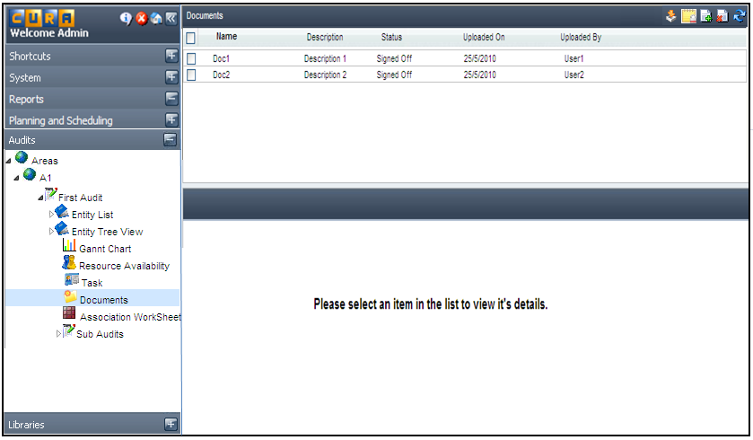
Figure 4 - Accessing Documents through the 'Documents' section under an Audit

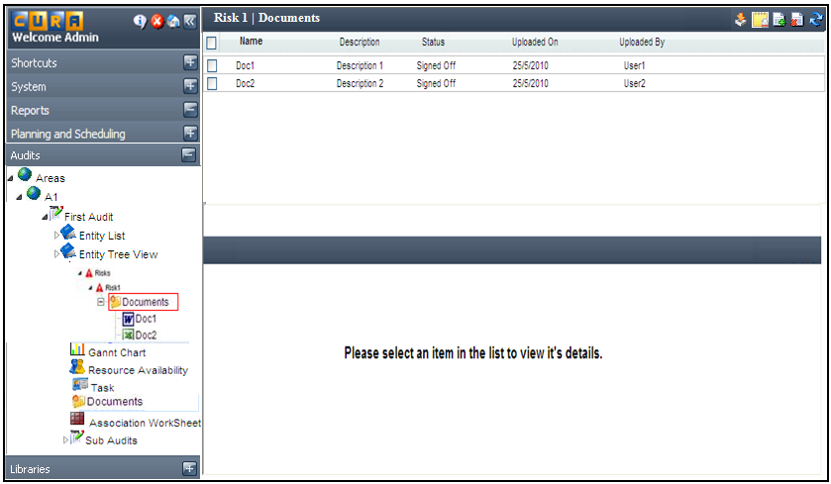
Figure 5 - Accessing Documents through 'Documents' node under an Entity Instance

Figure 6 - Accessing Documents through 'Documents' tab under an Entity Instance

FR_DMS_02: Create New Document Containers

Use Case Detail
Name | Create New Document Containers (Upload new documents)
Summary | The user can create new document containers (upload new documents) from the ‘Documents’ section under an Audit or ‘Documents’ node / ‘Documents’ tab under an entity instance
Actors | Document User
Preconditions | - The User is logged on to Internal Audit  - The User has access to the chosen Area  - The User has access to the chosen Audit / Sub Audit  - The User has selected ‘Documents’ section / ‘Documents’ node / ‘Documents’ tab
Triggers | Clicking the ‘Upload’ icon
Basic Flow | - User expands ‘Audits’ tab  - User expands ‘Area’  - User selects an Area  - User selects an Audit / Sub Audit  - User selects the ‘Documents’ section under the chosen Audit  - System displays the list of documents in the list pane.  - Users clicks on the ‘Upload’ icon  - System launches the explorer window  - User selects the documents he wants to upload and clicks the ‘Ok’ button  - System displays the list of the selected documents with a facility to enter the name and description for them  - System displays the file name of the uploaded documents against ‘Name’ by default which the user can change  - User enters the name and description for the documents uploaded and selects the ‘save’ option  - System creates the new document containers with the details provided and updates the list of documents.  - System captures other parameters – uploaded on, uploaded by, status
Alternate Flow | Alternate Flow 1:  - User expands ‘Audits’ tab  - User expands ‘Area’  - User selects an Area  - User selects an Audit / Sub Audit  - User selects ‘Entity Tree View’  - User selects an Entity  - User selects an Entity instance from the tree  - System displays a ‘Documents’ node if the selected entity instance has documents attached to it  - User selects ‘Documents’ node  - System displays the documents attached to the entity instance  - User clicks on the ‘Upload’ icon  - System launches the Explorer window  - User selects the documents to be uploaded and clicks on the ‘ok’ button  - System displays the list of the selected documents with a facility to enter the name and description for them  - System displays the file name of the document uploaded against ‘name’ by default  - User enters the name and description for the documents uploaded and selects the ‘save’ option  - System creates the new document containers with the details provided  - System captures other parameters – uploaded on, uploaded by, status  Alternate Flow 2:  - User expands ‘Audits’ tab  - User expands ‘Area’  - User selects an Area  - User selects an Audit /Sub Audit  - User selects ‘Entities List’ or ‘Entity Tree View’  - User selects an Entity  - System displays the Entity instances in the right pane  - User selects an Entity instance  - User selects the ‘Documents’ tab displayed in the ‘Details’ section  - User clicks on the ‘Upload’ icon  - System launches the Explorer window  - User selects the documents to be uploaded and clicks on the ‘OK’ button  - System displays the list of selected documents with a facility to enter the name and description for them  - System displays the file name of the uploaded documents against ‘name’ by default  - User enters the name and description for the uploaded documents and selects the ‘save’ option  - System creates the new document containers as per the details provided  - System captures other parameters – uploaded on, uploaded by, status
Post conditions | User will be able to create a new document containers (upload new documents) through the ‘Documents’ section under an Audit or through the ‘Documents’ node or ‘Documents’ tab under an entity instance
Business Rules | - The user should have access to the chosen entity instance  - The user should have ‘Create’ permission to upload a document  - The user should be able to upload a document/multiple documents of any format and any size  - A warning should be provided to the user if the doc size is more than 20 MB that it would have an impact on the system performance  - In case of multiple documents being uploaded, new document containers are created for each one of the documents.  - Once the document containers are created, the user can select a document and perform functions like adding a new version, linking to an entity instance etc ...  - Once a document is uploaded, its status is inherited from the entity instance under which it has been uploaded. However, the user can change the status of the doc. (Ref FR_DMS_06 – Manage Document Status)  - If the document is uploaded through the ‘Documents’ section and not linked to any entity instance, its status would be ‘Work Unplanned’ which could be changed by the user. (Ref FR_DMS_06 – Manage Document Status)

Graphical User Interface
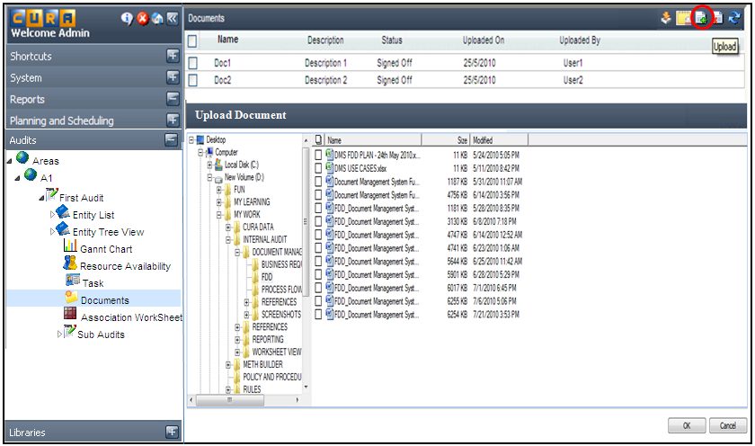
Figure 7 – Uploading Documents from the ‘Documents’ section under an Audit

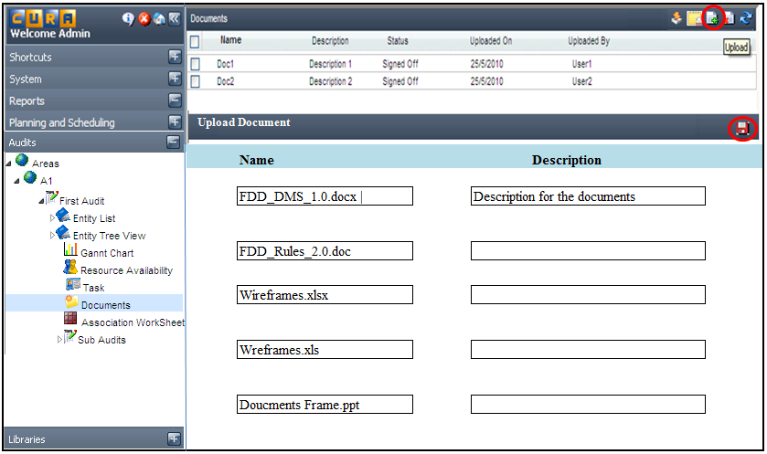
Figure 8 - Entering / Changing the name and description for the uploaded documents

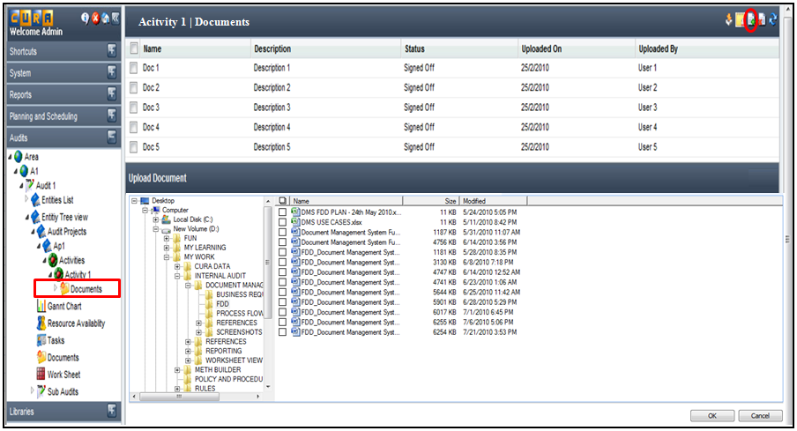
Figure 9 – Uploading Documents through 'Documents' node under an Entity instance

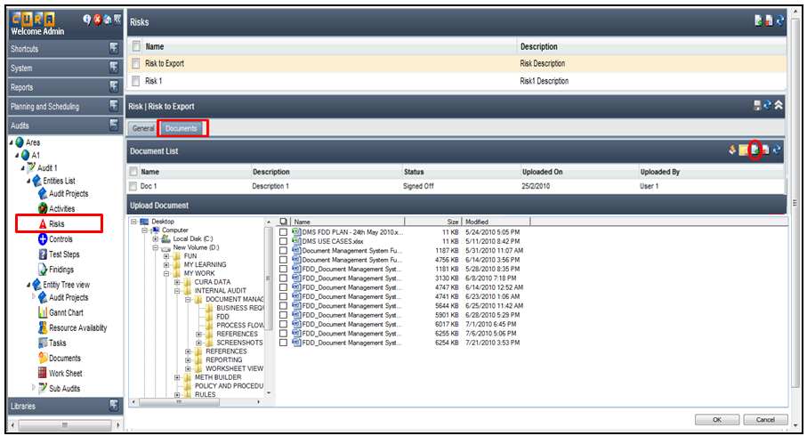
Figure 10 - Uploading Documents through 'Documents' tab under an Entity Instance

FR_DMS_03: Add New Version of a Document / Check in

Use Case Detail
Name | Upload New Version of a Document / Check in
Summary | The user can upload a new version of a document or check in a document either through the ‘Documents’ section under an Audit or through the ‘Documents’ node / ‘Documents’ tab under an Entity instance.
Actors | Document User
Preconditions | - The User is logged on to Internal Audit  - The User has access to the chosen Area  - The User has access to the chosen Audit / Sub Audit  - The User has selected ‘Documents’ section /‘Documents’ node /‘Documents’ tab  - The User has selected a document from the list
Triggers | Clicking on the ‘Add New Version / Check in’ icon
Basic Flow | - User expands ‘Audits’ tab  - User expands ‘Area’  - User selects an Area  - User selects an Audit / Sub Audit  - User selects the ‘Documents’ section under the chosen Audit  - System displays the documents under that Audit in the list pane  - Users selects a document from the list  - User clicks on the ‘Add New Version / Check in’ icon  - User enters the document details  - User selects if the change in document is ‘minor’ or ‘major’  - System increments the version number automatically based on user input.  - Once the system displays the version number based on the user selection, it will allow the User to change the auto generated version number.  - User changes / retains the auto generated version number  - User browses the file system, selects the new version of the documents and uploads it.  - System updates the document details.
Alternate Flow | Alternate Flow 1:  - User expands ‘Audits’ tab  - User expands ‘Area’  - User selects an Area  - User selects an Audit / Sub Audit  - User selects ‘Entity Tree View’  - User selects an Entity  - User selects an Entity instance from the tree  - System displays a ‘Documents’ node if the selected entity instance has documents attached to it  - User selects ‘Documents’ node  - System displays the documents attached to the entity instance  - User selects a document from the list  - User clicks on the ‘Add New Version / Check in’ icon  - User enters the document details  - User selects if the change in document is ‘minor’ or ‘major’  - System increments the version number automatically based on user input.  - Once the system displays the version number, it will allow the user to change the auto generated version number.  - User changes / retains the auto generated version number  - User browses the file system, selects the new version of the documents and uploads it.  - System updates the document details  Alternate Flow 2:  - User expands ‘Audits’ tab  - User expands ‘Area’  - User selects an Area  - User selects an Audit / Sub Audit  - User selects ‘Entities List’ or ‘Entity Tree View’  - User selects an Entity  - System displays the Entity instances in the right pane  - User selects an Entity instance  - User selects the ‘Documents’ tab displayed in the ‘Details’ section  - User selects a document from the list  - User clicks on the ‘Add New Version / Check in’ icon  - User enters the document details  - User selects if the change in document is ‘minor’ or ‘major’  - System increments the version number automatically based on user input.  - Once the system displays the version number based on the User selection, it will allow the User to change the auto generated version number.  - User changes / retains the auto generated version number  - User browses the file system, selects the new version of the document and uploads it.  - System updates the document details
Post conditions | User will be able to upload the new version of a document or check in a document
Business Rules | - The user should have permissions on the entity instance  - The user should have ‘create’ or ‘update’ permissions to upload a new version of a document or check in a document  - While uploading a new version / checking in, the user will be allowed to select only one document.  - When there are no documents attached, check in, check out and download icons are hidden.  - The document inherits its status from the entity instance under which it has been uploaded which can be changed by the user (Ref FR_DMS_06 – Manage Document Status)  - If the document has not been linked to any instance, the status of the newly uploaded version would be ‘work in progress’ which can be changed by the user. (Ref FR_DMS_06 – Manage Document Status)  - If a document is linked to multiple instances with different statuses, the document inherits the status of the last linked instance which can be changed by the user (Ref FR_DMS_06 – Manage Document Status)  - If a document has been checked out to a user then only he will be able to upload the next version. The ‘Add New Version / Check In’ functionality would be disabled for the other users on that document. However, the user with ‘Unlock’ permission can override the check out. (Ref FR_DMS_10 – Check Out a Document)  - The version number of the document gets incremented automatically based on the existing version of the document and user selection of ‘minor’ vs ‘major’ change. However, the auto generated version number can be changed by the user. Every document will have a reference number allocated once it has been uploaded into the system.  - If the user selects the change to be ‘minor’, the version number gets incremented by 0.1.  For eg: if the existing version of a document is 1.5 and the user selects the change to be ‘minor’ then the version number gets incremented to 1.6.  - If the user selects the change to be ‘major’, the version number gets incremented to the next integer.  For e.g.; if the existing version of a document is 1.5 and the user selects the change to be ‘major’ then the version number gets incremented to 2.0.  - Once the auto generated version number is displayed, the ‘Version Number’ field would be editable so that the user can change it if necessary.  - When a user is trying to change the automatically generated version number, he should not be allowed to move back to a previous version.

Graphical User Interface
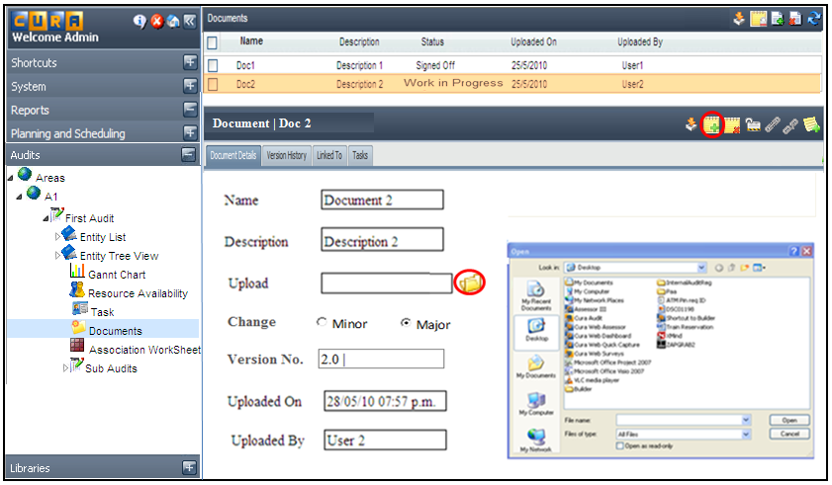
Figure 11 - Check in Document through 'Documents' section under an Audit

FR_DMS_04: Linking / Associating Documents and Entity Instances

Use Case Detail
Name | Linking / Associating Documents and Entity Instances
Summary | The user can upload a document from the ‘Documents’ section under an Audit or from the ‘Documents’ node/’Documents’ tab under an Entity instance under the ‘Entity Tree View’ or ‘Entities List’.  The document is automatically linked to the entity instance under which it has been uploaded. It can also be linked to other entity instances in the Audit through the ‘Link To’ tab which brings up the list of entity instances. The list of instances being displayed is dependent on the fact that the Entity has been configured (in Meth Builder) to have documents under it. The user selects entity instances to which the document has to be linked and saves it which updates the chosen entity instances.  Once the linking is completed, the chosen entity instances would have a ‘Documents’ node or ‘Documents’ tab under them through which the document which is linked can be accessed.  The user can also link documents to an Entity instance using the Link
Actors | Document User
Preconditions | - The User is logged on to Internal Audit  - The User has access to the chosen Area  - The User has access to the chosen Audit / Sub Audit  - The User has selected ‘Documents’ section / ‘Documents’ node / ‘Documents’ tab  - The User has selected a document from the list
Triggers | Clicking the ‘Link To’ tab
Basic Flow | - User expands ‘Audits’ tab  - User expands ‘Area’  - User selects an Area  - User selects an Audit / Sub Audit  - User selects the ‘Documents’ section under the chosen Audit  - System displays the list of documents in the list pane  - Users selects a document from the list  - User selects the ‘Link To’ tab  - System displays the list of instances if the document has already been linked to any  - User clicks on the 'Link' icon  - System displays the Entity Tree View with the instances of entities that have been configured to have Documents.  - User selects the entity instances and clicks on ‘Save’ icon  - System updates the chosen Entity Instances  - ‘Documents’ node or ‘Documents’ tab would be available under the linked instances through which the linked documents can be accessed.
Alternate Flow | Alternate Flow 1:  - User expands ‘Audits’ tab  - User expands ‘Area’  - User selects an Area  - User selects an Audit / Sub Audit  - User selects ‘Entity Tree View’  - User selects an Entity  - User selects an Entity instance from the tree  - System displays a ‘Documents’ node if the selected entity instance has documents attached to it  - User selects ‘Documents’ node  - System displays the documents attached to the entity instance  - User selects a document from the tree  - User selects the ‘Link To’ tab  - System displays the list of instances if the document has already been linked to any  - User clicks on the 'Link' icon  - System displays the Entity Tree View with the instances of entities that have been configured to have Documents. System displays the list of entity instances  - User selects the entity instances and clicks on ‘Save’ icon  - System updates the chosen Entity Instances  - ‘Documents’ node or ‘Documents’ tab would be available under the linked instances through which the linked documents can be accessed.  Alternate Flow 2:  - User expands ‘Audits’ tab  - User expands ‘Area’  - User selects an Area  - User selects an Audit / Sub Audit  - User selects ‘Entities List’ or ‘Entity Tree View’  - User selects an Entity  - System displays the Entity instances in the right pane  - User selects an Entity instance  - User selects the ‘Documents’ tab displayed in the ‘Details’ section  - System displays the list of documents attached to the entity instance  - User selects a document from the list  - User selects the ‘Link To’ tab  - System displays the list of instances if the document has already been linked to any  - User clicks on the 'Link' icon  - System displays the Entity Tree View with the instances of entities that have been configured to have Documents.  - System displays the list of entity instances  - User selects the entity instances and clicks on ‘Save’ icon  - System updates the chosen Entity Instances  - ‘Documents’ node or ‘Documents’ tab would be available under the linked instances through which the linked documents can be accessed.  Alternate Flow 3:  - User expands ‘Audits’ tab  - User selects an Audit  - User expands ‘Area’  - User selects an Area  - User selects Audit / Sub Audit  - User selects ‘Entities List’ or ‘Entity Tree View’  - User selects an Entity  - User selects an Entity Instance  - User selects ‘Documents’ tab in the Details section  - User clicks on ‘Link’ icon  - System displays the list of all the documents available under the Audit  - User selects the documents and clicks on the ‘save’ icon  - The chosen documents will be linked to the instance which can be accessed in different ways as described in ‘Access Documents’ use case (Ref FR_DMS_01 – Access ‘Documents’)
Post conditions | User will be able to link a document to multiple entity instances or add multiple documents to an Entity instance
Business Rules | - The list of documents under the ‘Documents’ section/node/tab should be displayed based on the permissions that the user has  - The entity instances displayed on clicking the ‘Link’ icon should be displayed only if the entities have been configured (in Meth Builder) to have documents under them  - The list of entity instances under the ‘Link To’ tab should be displayed based on the permission that the user has.  - The ‘Link’ icon would be available only if the entity has been configured to have documents under it  - The user should have ‘create’/‘update’ permission on an entity to link documents

Graphical User Interface
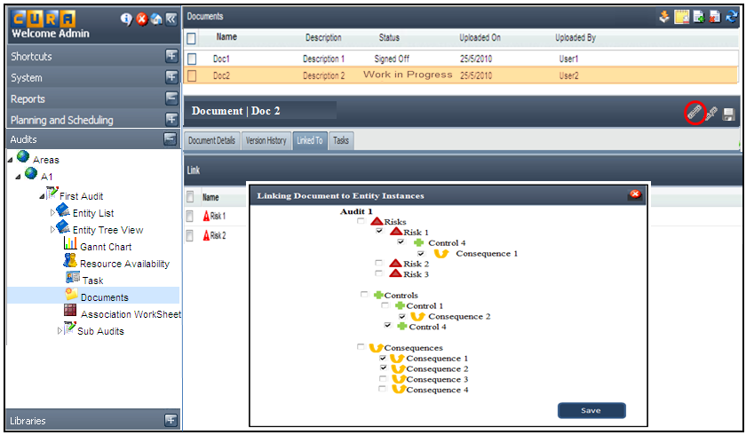
Figure 12 – Linking Entity Instances to a Document

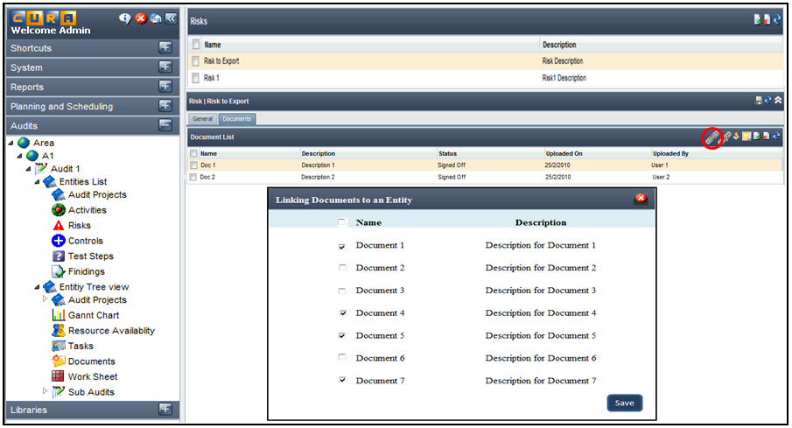
Figure 13 – Linking Documents to an Entity Instance

FR_DMS_05: Trigger a Task

Use Case Detail
Name | Trigger a Task
Summary | The user can trigger a task for a document review or sign off by clicking on the ‘Add Task’ icon which brings up the Task Management flow.
Actors | Document User
Preconditions | - The User is logged on to Internal Audit  - The User has access to the chosen Area  - The User has access to the chosen Audit / Sub Audit  - The User has selected ‘Documents’ section / 'Documents' node / 'Documents' tab  - The User has selected a document from the list
Triggers | Clicking the ‘Add Task’ icon
Basic Flow | - User expands ‘Audits’ tab  - User expands ‘Area’  - User selects an Area  - User selects an Audit / Sub Audit  - User selects the ‘Documents’ section / 'Documents' node / 'Documents' tab  - System displays the list of documents  - Users selects a document from the list  - User selects 'Tasks' tab in the Details section which displays the list of tasks under the chosen document  - User clicks on ‘Add Task’ icon  - System launches the ‘Add Task’ window wherein the user enters the details  - Refer to the Tasking FSD – section 1.2 (Tasking FS attached in section # 5.1), which will cover the tasking configuration.  - Once a task is created, it is displayed under the ‘Tasks’ tab and ‘Tasks’ node of all the entity instances to which the document is linked.
Alternate Flow | Alternate Flow 1:  - User expands ‘Audits’ tab  - User expands ‘Area’  - User selects an Area  - User selects an Audit / Sub Audit  - User selects ‘Entity Tree View’  - User selects an Entity  - User selects an Entity instance from the tree  - System displays a ‘Documents’ node if the selected entity instance has documents attached to it  - User selects ‘Documents’ node  - System displays the documents attached to the entity instance  - User selects a document from the tree  - User clicks on ‘Add Task’ icon  - System launches the ‘Add Task’ window wherein the user enters the details  - Refer to the Tasking FSD – Section 1.2 (Tasking FS attached in section # 5.1)  - Once a task is created, it is displayed under the ‘Tasks’ tab and ‘Tasks’ node of all the entity instances to which the document is linked.  Alternate Flow 2:  - User expands ‘Audits’ tab  - User expands ‘Area’  - User selects an Area  - User selects an Audit / Sub Audit  - User selects ‘Entities List’ or ‘Entity Tree View’  - User selects an Entity  - System displays the Entity instances in the right pane  - User selects an Entity instance  - User selects the ‘Documents’ tab displayed in the ‘Details’ section  - System displays the list of documents attached to the entity instance  - User selects a document from the list  - User clicks on ‘Add Task’ icon  - System launches the ‘Add Task’ window wherein the user enters the details  - Refer to the Tasking FSD – Section 1.2 (Tasking FS attached in section # 5.1)  - Once a task is created, it is displayed under the ‘Tasks’ tab and ‘Tasks’ node of all the entity instances to which the document is linked.
Post conditions | The user will be able to trigger a task on a document for its review and signoff
Business Rules | - The list of documents should be displayed based on the permission that the user has  - The user should have ‘Create’ permission to trigger a task  - Once a task is created, it is displayed under the ‘Tasks’ tab and ‘Tasks’ node of all the entity instances to which the document is linked.

Graphical User Interface
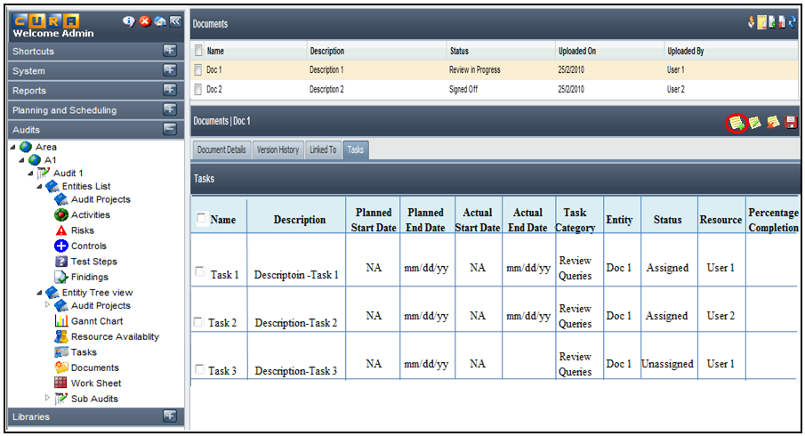
Figure 14 - Clicking on 'Add Task' icon to trigger a task
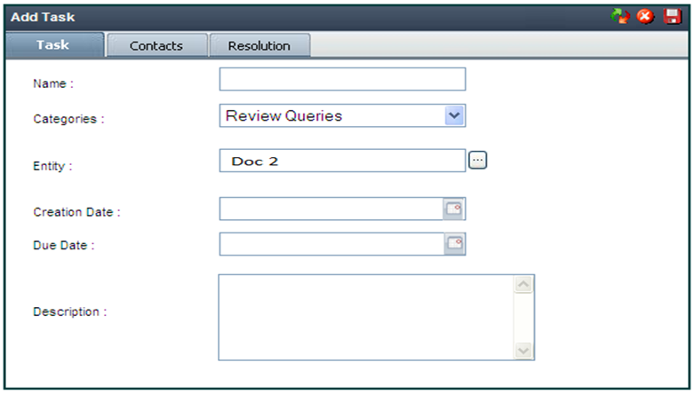
Figure 15 - Entering Details in the 'Add Task' window

FR_DMS_06: Manage Document Status

Use Case Detail
Name | Manage Document Status
Summary | The status of the document changes throughout its life cycle. The user can change the status of the document through the ‘Details’ section or the Association Worksheet. A document can have the following status:  - Work Unplanned  - Work not started  - Work in Progress  - Work Completed  - Review not started  - Review in Progress  - Review Completed  - Signed Off
Actors | Document User
Preconditions | - User should be logged on to Internal Audit  - User should have access to the chosen area  - User should have access to the chosen Audit / Sub Audit  - User should have selected ‘Documents’ section / ‘Documents’ node / ‘Documents’ tab  - User should have selected a document from the list
Triggers | - Selecting a document and clicking the ‘Document Details’ tab
Basic Flow | - User expands the ‘Audits’ tab  - User expands ‘ Area’  - User selects an Area  - User selects an Audit / Sub Audit  - User selects the ‘Documents’ section  - System displays the list of documents under the chosen Audit in the list pane  - User selects a document from the list  - User clicks on the ‘Document Details’ tab  - User selects the new status from the dropdown  - User clicks on the ‘save’ icon  - System updates the document status across all the entity instances to which it is linked
Alternate Flow | Alternate Flow 1:  - User expands ‘Audits’ tab  - User expands ‘Area’  - User selects an Area  - User selects an Audit / Sub Audit  - User selects ‘Entity Tree View’  - User selects an Entity  - User selects an Entity instance from the tree  - System displays a ‘Documents’ node if the selected entity instance has documents attached to it  - User selects ‘Documents’ node  - System displays the documents attached to the entity instance  - User selects a document from the tree  - User clicks on ‘Document Details’ tab  - User selects the new status from the dropdown  - User clicks on the ‘save’ icon  - System updates the document status across all the entity instances to which it is linked  Alternate Flow 2:  - User expands ‘Audits’ tab  - User expands ‘Area’  - User selects an Area  - User selects an Audit /Sub Audit  - User selects ‘Entities List’ or ‘Entity Tree View’  - User selects an Entity  - System displays the Entity instances in the right pane  - User selects an Entity instance  - User selects the ‘Documents’ tab displayed in the ‘Details’ section  - System displays the list of documents attached to the entity instance  - User selects a document from the list  - User selects the new status from the dropdown  - User clicks on the ‘save’ icon  - System updates the document status across all the entity instances to which it is linked  Alternate Flow 3:  - User expands ‘Audit’ tab  - User expands ‘Area’  - User selects an Area  - User selects an Audit / Sub Audit  - User selects ‘Entities List’ / ‘Entity Tree View’/ ‘Association Work Sheet’  - User selects an Entity Instance from the list  - User selects ‘General’ tab in the ‘Details’ section  - User selects the status from the ‘Audit Entity Status’ dropdown  - User clicks the ‘save’ icon which updates the status of the Entity  - If the chosen entity instance has a document attached, then signing off the instance would signoff the document as well, provided it is not linked to any other instance
Post conditions | The status of the document is updated across all the entity instances to which it is linked
Business Rules | - The list of documents is displayed based on the permission that the user has  - Once a document is signed off, no changes can be made to the document unless the user has ‘unlock’ permission with which he can change the doc status to a previous one and act upon it.  - Once the document status is updated, the same is displayed across all the entity instances to which it has been linked  - If the document is linked to a single entity instance, signing off the entity instance would automatically change the document status to ‘signed off’  - If the document is linked to multiple entity instances, signing off the last entity instance would sign off the document else signing off one of the instances would not change the document status.

Graphical User Interface
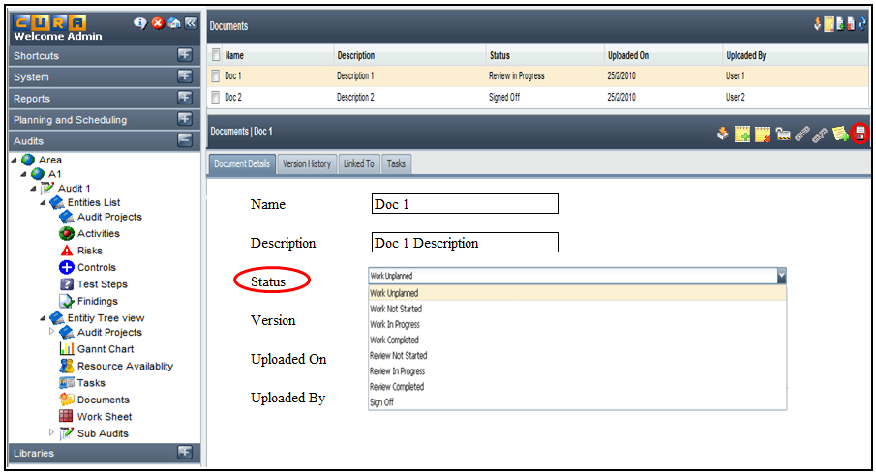
Figure 16 - Managing Document Status

FR_DMS_07: View Document Details

Use Case Detail
Name | View Document Details
Summary | The user can select a particular document from the list under the ‘Documents’ section or ‘Documents’ node / ‘Documents’ tab under an entity instance and view it’s details. The document details are available under 4 tabs – ‘Document Details’, ‘Version History’, ‘Link To’ and ‘Tasks’
Actors | Document User
Preconditions | - The User is logged on to Internal Audit  - The User has access to the chosen Area  - The User has access to the chosen Audit / Sub Audit  - The User has selected ‘Documents’ section / ‘Documents’ node / ‘Documents’ tab
Triggers | Selecting the ‘Documents’ section / ‘Documents’ node / ‘Documents’ tab
Basic Flow | - User expands ‘Audits’ tab  - User expands ‘Area’  - User selects an Area  - User selects an Audit / Sub Audit  - User selects the ‘Documents’ section under the chosen Audit  - System displays the list of documents under the Audit in the list pane  - User selects a document from the list  - System displays the details of the selected documents under 4 tabs – ‘Document Details’, ‘Version History’, ‘Link To’ and ‘Tasks’
Alternate Flow | Alternate Flow 1:  - User expands ‘Audits’ tab  - User expands ‘Area’  - User selects an Area  - User selects an Audit / Sub Audit  - User selects ‘Entity Tree View’  - User selects an Entity  - User selects an Entity instance from the tree  - System displays a ‘Documents’ node if the selected entity instance has documents attached to it  - User selects ‘Documents’ node  - System displays the documents attached to the entity instance  - User selects a document from the tree  - User can see the details of the selected documents under 4 tabs – ‘Document Details’, ‘Version History’, ‘Link To’ and ‘Tasks’  Alternate Flow 2:  - User expands ‘Audits’ tab  - User expands ‘Area’  - User selects an Area  - User selects an Audit / Sub Audit  - User selects ‘Entities List’ or ‘Entity Tree View’  - User selects an Entity  - System displays the Entity instances in the right pane  - User selects an Entity instance  - User selects the ‘Documents’ tab displayed in the ‘Details’ section  - System displays the list of documents attached to the entity instance  - User selects a document from the list  - User can see the details of the selected documents under 4 tabs – ‘Document Details’, ‘Version History’, ‘ Link To’ and ‘Tasks’
Post conditions | User will be able to view the details of a chosen document under 4 tabs – ‘Document Details’, ‘Version History’, ‘Link To’ and ‘Tasks’
Business Rules | - The list of documents under the ‘Documents’ section should be displayed based on the permissions that the user has.  - The user should have at least ‘View’ permissions to view the document details.

Graphical User Interface
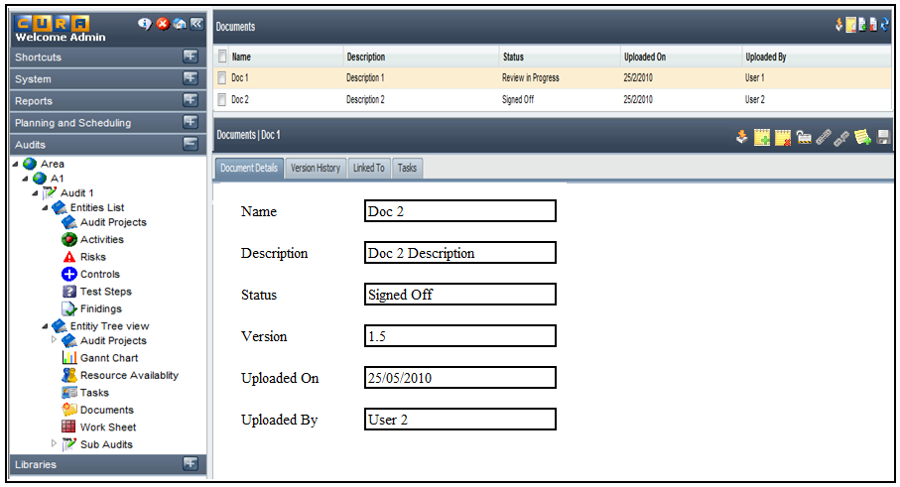
Figure 17 - Viewing Document Details - 'Document Details' tab

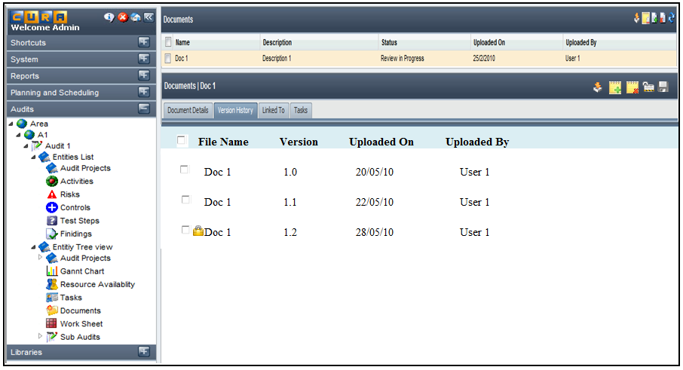
Figure 18 - Viewing Document Details - 'Version History’ tab

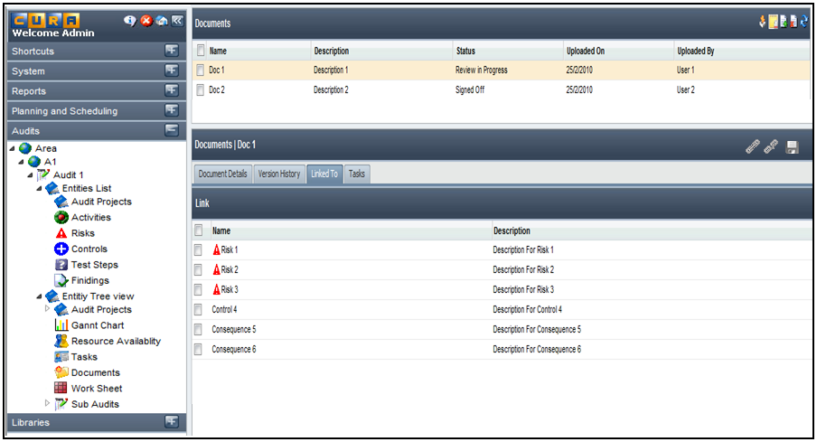
Figure 19 - Viewing Document Details - 'Link To' tab

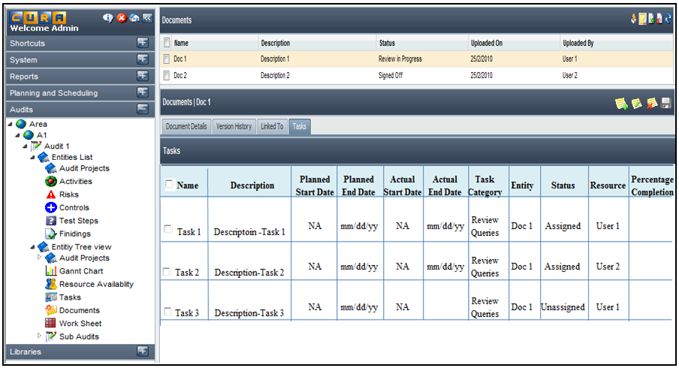
Figure 20 - Viewing Document Details - 'Tasks' tab

FR_DMS_08: View Version History

Use Case Detail
Name | View Version History
Summary | The user can view the version history of a document by selecting it from the list under the ‘Documents’ section under an Audit or ‘Documents’ node / ‘Documents’ tab under an Entity instance
Actors | Document User
Preconditions | - The User is logged on to Internal Audit  - The User has access to the chosen Area  - The User has access to the chosen Audit / Sub Audit  - The User has selected ‘Documents’ section/’Documents’ node/’Documents’ tab  - The User has selected a document from the list
Triggers | Selecting a document from the list
Basic Flow | - User expands ‘Audits’ tab  - User expands ‘Area’  - User selects an Area  - User selects an Audit / Sub Audit  - User selects the ‘Documents’ section under the chosen Audit  - Users selects a document from the list  - Use selects the ‘Version History’ tab  - System displays the list of all the versions of the document chosen, with details like version number, document name, uploaded on, uploaded by
Alternate Flow | Alternate Flow 1:  - User expands ‘Audits’ tab  - User expands ‘Area’  - User selects an Area  - User selects an Audit / Sub Audit  - User selects ‘Entity Tree View’  - User selects an Entity  - User selects an Entity instance from the tree  - System displays a ‘Documents’ node if the selected entity instance has documents attached to it  - User selects ‘Documents’ node  - System displays the documents attached to the entity instance  - User selects a document from the tree  - User selects the ‘Version History’ tab  - System displays the list of all the versions of the document chosen, with details like version number, document name, uploaded on, uploaded by  - Alternate Flow 2:  - User expands ‘Audits’ tab  - User expands ‘Area’  - User selects an Area  - User selects an Audit / Sub Audit  - User selects ‘Entities List’ or ‘Entity Tree View’  - User selects an Entity  - System displays the Entity instances in the right pane  - User selects an Entity instance  - User selects the ‘Documents’ tab displayed in the ‘Details’ section  - System displays the list of documents attached to the entity instance  - User selects a document from the list  - User selects the ‘Version History’ tab
Post conditions | User will be able to view the version history of a document in terms of version number, uploaded on, and uploaded by.
Business Rules | - The list of documents under the ‘Documents’ section should be displayed based on the permissions that the user has  - The user should have at least ‘View’ permission to view the version details of a document.

Graphical User Interface
Figure 21 - Viewing Version History of a document

FR_DMS_09: Download Document

Use Case Detail
Name | Download Document
Summary | The user can select a particular document from the list under the ‘Documents’ section or ‘Documents’ node or ‘Documents’ tab under ‘Entity Tree View’ / ‘Entities List’ and download it wherein he will have the option to open the document or save it to his local File system.  The user can also download a particular version of the document by selecting it from the ‘Version History’ tab.
Actors | Document User
Preconditions | - The User is logged on to Internal Audit  - The User has access to the chosen Area  - The User has access to the chosen Audit / Sub Audit  - The User has selected ‘Documents’ section / ‘Documents’ node / ‘Documents’ tab  - The User has selected a document from the list
Triggers | - Selecting a document and clicking on the ‘Download’ icon  - Selecting a version from the ‘Version History’ tab in the details section of the document and clicking the ‘Download’ icon
Basic Flow | - User expands ‘Audits’ tab  - User expands ‘Area’  - User selects an Area  - User selects an Audit / Sub Audit  - User selects the ‘Documents’ section under the chosen Audit  - Users selects a document from the list or selects a version from the ‘Version History’ tab in the ‘Details’ section  - System displays the list of available versions if the user selects the ‘Version History’ tab  - User selects a version and clicks on the ‘Download’ icon  - User can choose to open the document or save it to a local file system
Alternate Flow | Alternate Flow 1:  - User expands ‘Audits’ tab  - User expands ‘Area’  - User selects an Area  - User selects an Audit / Sub Audit  - User selects ‘Entity Tree View’  - User selects an Entity  - User selects an Entity instance from the tree  - System displays a ‘Documents’ node if the selected entity instance has documents attached to it  - User selects ‘Documents’ node  - System displays the documents attached to the entity instance  - User selects a document from the tree or selects a version from the ‘Version History’ tab in the ‘Details’ section  - System displays the list of available versions if the user selects the ‘Version history’ tab  - User selects a version and clicks on the ‘Download’ icon  - User can choose to open the document or save it to a local file system  Alternate Flow 2:  - User expands ‘Audits’ tab  - User expands ‘Area’  - User selects an Area  - User selects an Audit / Sub Audit  - User selects ‘Entities List’ or ‘Entity Tree View’  - User selects an Entity  - System displays the Entity instances in the right pane  - User selects an Entity instance  - User selects the ‘Documents’ tab displayed in the ‘Details’ section  - System displays the list of documents attached to the entity instance  - User selects a document from the list or selects a version from the ‘Version History’ tab in the ‘Details’ section  - System displays the list of available versions if the user selects the ‘Version History’ tab  - User selects a version and clicks on the ‘Download’ icon  - User can choose to open the document or save it to a local file system
Post conditions | User will be able to download the document and open it or save it to the local file system.
Business Rules | - The list of documents under the ‘Documents’ section should be displayed based on the permissions that the user has  - The user should have the permission to download the document.  - The user should have at least ‘View’ permission to download a document  - If the user doesn’t have the permission to download the document then a message is displayed informing the user about the same.  - The user can download the current version of the document by selecting it from the list and clicking on the ‘Download’ icon  - The user can download a previous version by selecting it from the ‘Version History’ tab under the Details section and clicking the ‘Download’ icon  - The user can download multiple documents at a time

Graphical User Interface
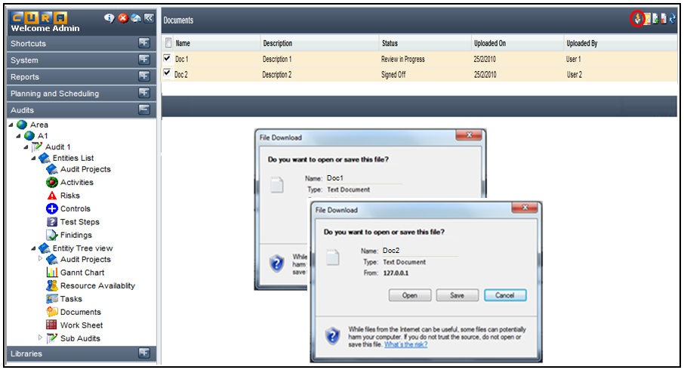
Figure 22 - Downloading the active versions of documents

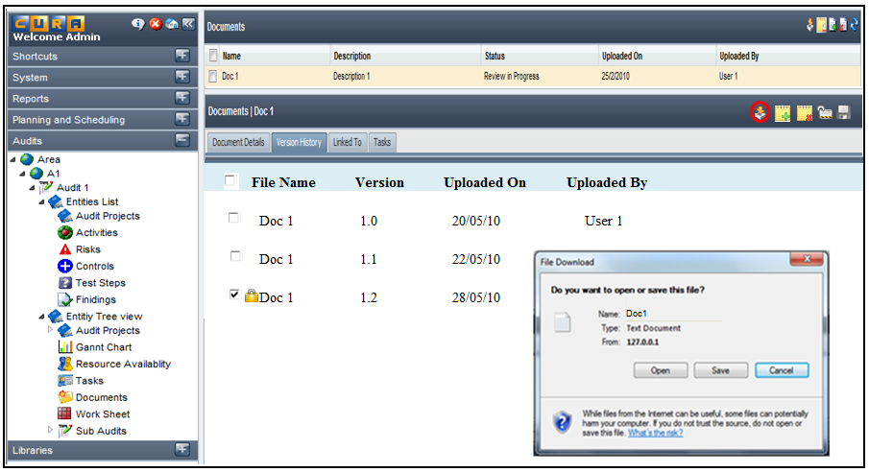
Figure 23 - Downloading previous version of the document

FR_DMS_10: Check Out Documents

Use Case Detail
Name | Check out Documents
Summary | The user can select documents from the ‘Documents’ section under an Audit or ‘Documents’ tab/node under an Entity instance and check it out by clicking on the ‘Check out’ icon.  Once a document is checked out, the ‘Upload New Version/ Check in’ is disabled for all users except for the one who has checked it out. The other users will only be able to view the document and if the user tries to act on the document, the system would not allow and would display a message that the document has been checked out to <user name>  However the other users will be able to view the document and download it.
Actors | Document User
Preconditions | - The User is logged on to Internal Audit  - The User has access to the chosen Area  - The User has access to the chosen Audit / Sub Audit  - The User has selected ‘Documents’ section / ‘Documents’ tab / ‘Documents’ node  - The User has selected the required documents from the list
Triggers | Clicking the ‘Check Out’ icon
Basic Flow | - User expands ‘Audits’ tab  - User expands ‘Area’  - User selects an Area  - User selects an Audit / Sub Audit  - User selects the ‘Documents’ section under the chosen Audit  - System displays the list of documents  - Users selects the required documents from the list  - User clicks on ‘Check out’ icon  - System opens the selected document/s which the user can save to his local file system  - Once a document is checked out, system displays a lock icon against the document/s indicating that they have been checked out and cannot be used
Alternate Flow | Alternate Flow 1:  - User expands ‘Audits’ tab  - User expands ‘Area’  - User selects an Area  - User selects an Audit / Sub Audit  - User selects ‘Entity Tree View’  - User selects an Entity  - User selects an Entity instance from the tree  - System displays a ‘Documents’ node if the selected entity instance has documents attached to it  - User selects ‘Documents’ node  - System displays the documents attached to the entity instance  - User selects the required document from the list  - User clicks on ‘Check out’ icon  - System opens the selected documents which the user can save to his local file system  - Once a document is checked out, system displays a lock icon against the document indicating that it has been checked out and cannot be used  Alternate Flow 2:  - User expands ‘Audits’ tab  - User expands ‘Area’  - User selects an Area  - User selects an Audit / Sub Audit  - User selects ‘Entities List’ or ‘Entity Tree View’  - User selects an Entity  - System displays the Entity instances in the right pane  - User selects an Entity instance  - User selects the ‘Documents’ tab displayed in the ‘Details’ section  - System displays the list of documents attached to the entity instance  - User selects the required documents from the list  - User clicks on ‘Check out’ icon  - System opens the selected documents which the user can save to his local file system  - Once a document is checked out, system displays a lock icon against the document indicating that it has been checked out and cannot be used
Post conditions | User will be able to check out a document / multiple documents
Business Rules | - The list of documents under the ‘Documents’ section/node/tab should be displayed based on the permissions that the user has  - The user should have ‘Update’ permission to check out a document  - The user can check out multiple documents simultaneously  - Once a user checks a document out, a lock icon appears against the document indicating that it has been checked out and cannot be used  - On pointing at the lock icon, message should be displayed on the tool tip that the document has been checked out to <user name>  - The user can check out only the currently active version of the document  - Once a document is checked out, the other users will only be able to view / download the document. If the users try to act on the document the system would not allow and would display a message that the document has been checked out to <user name>  - When a document has been checked out by a user only he would have the ‘Add New Version / Check in’ function active. It is disabled for other users.  - A user with ‘Unlock’ permissions can override the check out of a document by selecting the checked out document and clicking on the ‘Unlock’ icon. On clicking the icon, a message is displayed asking the user if he wants to cancel the check out. If he selects ‘YES’, the check out would be overridden and the document would once again be available to all users.

Graphical User Interface
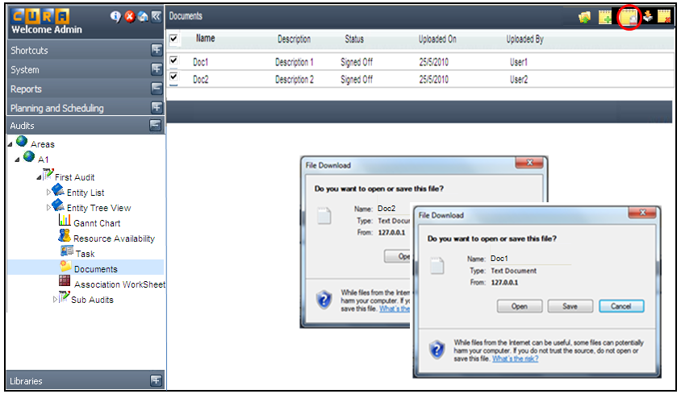
Figure 24 - Checking Out Documents

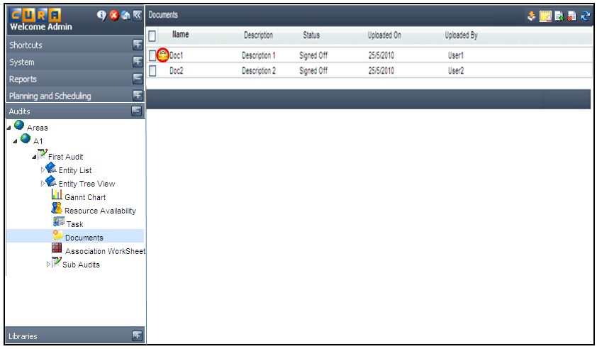
Figure 25 - Displaying Checked Out Document with a Lock Icon
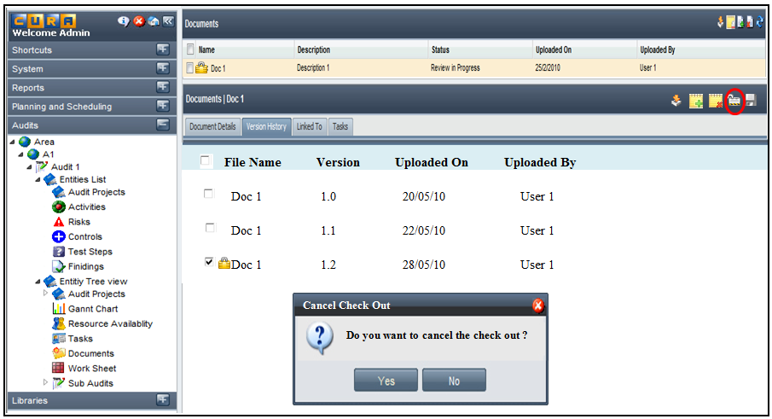
Figure 26 - Overriding a Check Out

FR_DMS_11: Delete a Document or a Document Version

Use Case Detail
Name | Delete a Document or a Document Version
Summary | The user can select a document from the list under the ‘Documents’ section under an Audit or ‘Documents’ node/’Documents’ tab under an Entity instance and click on the ‘Delete’ icon to delete it.  If a user deletes a document from the ‘Documents’ section under an Audit, it would be completely deleted and all the associations would be removed.  However, if a user deletes a document under an Entity instance, only the association between the document and the instance would be removed. The document would still be available under the ‘Documents’ section under an Audit and under the other Entity Instances to which it is linked.  A user with ‘Manage All’ permissions can delete the previous versions of the document as well. The details of all the versions of the document are available under the ‘Version History’ tab in the ‘Details’ section. The user can choose a particular version or all the available versions and click on the ‘Delete’ icon to remove them from the system.
Actors | Document User
Preconditions | - The User is logged on to Internal Audit  - The User has access to the chosen Area  - The User has access to the chosen Audit / Sub Audit  - The User has selected ‘Documents’ section/’Documents’ node/’Documents’ tab  - The User has selected a document from the list  - The User selects the ‘Version History’ tab
Triggers | Selecting a document / document version and clicking the ‘Delete’ icon
Basic Flow | - User expands ‘Audits’ tab  - User expands ‘Area’  - User selects an Area  - User selects an Audit / Sub Audit  - User selects the ‘Documents’ section under the chosen Audit  - System displays the list of documents in the list pane  - User selects a document from the list and clicks on ‘Delete’ icon  - System displays a message asking the user to confirm deletion  - Once the user confirms the deletion, system deletes the document and removes all the associations.  - System updates the list of documents under the ‘Documents’ section and also the Entity instances which were associated
Alternate Flow | Alternate Flow 1:  - User expands ‘Audits’ tab  - User expands ‘Area’  - User selects an Area  - User selects an Audit / Sub Audit  - User selects ‘Entity Tree View’  - User selects an Entity  - User selects an Entity instance from the tree  - System displays a ‘Documents’ node if the selected entity instance has documents attached to it  - User selects ‘Documents’ node  - System displays the documents attached to the entity instance  - User selects a document from the list and clicks on ‘Delete’ icon  - System displays a message asking the user to confirm deletion  - Once the user confirms deletion, the document is removed from the list under the Entity Instance  - System updates the list of documents under the Entity Instance  Alternate Flow 2:  - User expands ‘Audits’ tab  - User expands ‘Area’  - User selects an Area  - User selects an Audit / Sub Audit  - User selects ‘Entity List’ or ‘Entity Tree View’  - User selects an Entity  - System displays the Entity instances in the list pane  - User selects an Entity instance  - User selects the ‘Documents’ tab displayed in the ‘Details’ section  - System displays the list of documents attached to the entity instance  - User selects a document from the list and clicks on ‘Delete’ icon  - System displays a message asking the user to confirm deletion  - Once the user confirms the deletion, the document is removed from the list under the Entity Instance  - System updates the document list under the Entity Instance  Alternate Flow 3:  - User expands ‘Audits’ tab  - User expands ‘Area’  - User selects an Area  - User selects an Audit / Sub Audit  - User selects the ‘Documents’ section under the chosen Audit  - System displays the list of documents in the list pane  - User selects a document from the list  - System displays the document details  - User selects the ‘Version History’ tab  - System displays the list of available versions  - User selects a particular version or all the available versions and clicks the ‘Delete’ icon  - System displays a message asking the user to confirm deletion  - Once the user confirms deletion, system deletes the selected versions  - System updates the document details
Post conditions | User will be able to delete a document or a selected version of the chosen document
Business Rules | - The list of documents under the ‘Documents’ section should be displayed based on the permissions that the user has  - Deleting a document under an Entity Instance would only remove the link/association between the document and the instance  - The document deleted under an Entity Instance would still be available under the ‘Documents’ section under an Audit and also under the other Entity Instances which are linked  - Deleting a document from the ‘Documents’ section under an Audit would remove it permanently from the system and remove all the associations  - A user with ‘Manage All’ permission would be able to delete the previous versions of the document  - A document whose status is ‘Work in Progress’ can be deleted by any user who has ‘Delete’ permission  - A document in review stage can be deleted only by users who have ‘Review’ and ‘Delete’ permissions.  - The document version which has been ‘Signed Off’ cannot be deleted. However, the other versions can be deleted by a user with ‘Manage All’ permissions

Graphical User Interface
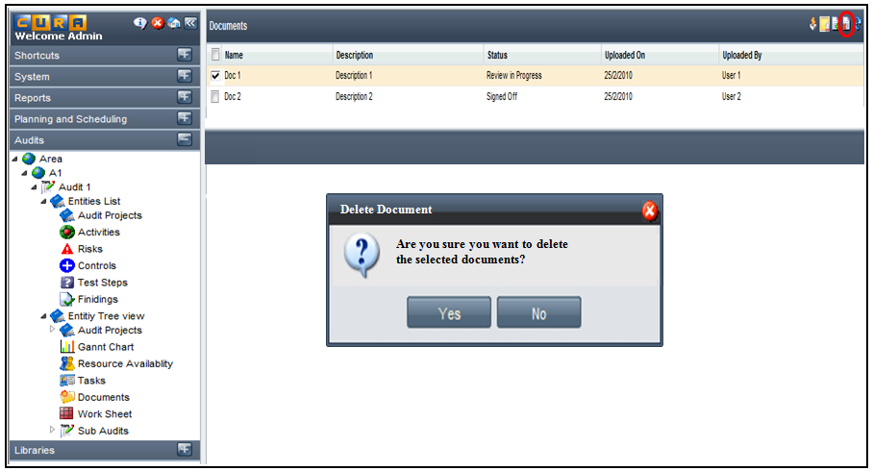
Figure 27 - Deleting a document

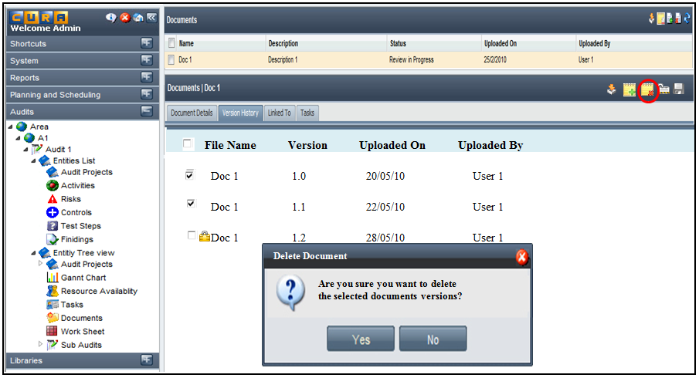
Figure 28 - User with 'Manage All' permissions deleting the previous versions of a document

FR_DMS_12: Remove Association between Documents & Entity Instances

Use Case Detail
Name | Remove Associations between Documents and Entity Instances
Summary | The user can select a document from the list under the ‘Documents’ section under an Audit or ‘Documents’ node / ‘Documents’ tab under an Entity Instance to view its details under 4 tabs namely – ‘Document Details’, ‘Version History’, ‘Linked To’ and ‘Tasks’. The ‘Linked To’ tab shows the list of entity instances that are linked to the chosen document.  The user can click the ‘Remove Association’ icon which brings up the list of linked entity instances. The user can deselect the instances which need not be linked and click on the ‘save’ button so that the association between the document and the selected entity instances is removed.  The user can link documents to an Entity Instance from the instance. In the same way, he can delink the documents from an Entity Instance by selecting the ‘Remove Association’ icon on the ‘Documents’ tab under the Entity Instance. The list of linked documents is displayed on clicking the icon. The user can deselect the documents which need not be linked and click on the ‘save’ button so that the association between the instance and the selected documents is removed
Actors | Document User
Preconditions | - The User is logged on to Internal Audit  - The User has access to the chosen Area  - The User has access to the chosen Audit / Sub Audit  - The User has selected ‘Documents’ section/’Documents’ node/’Documents’ tab  - The User has selected a document from the list  - The User has selected ‘Linked To’ tab  - The User has selected ‘Documents’ tab under an Entity Instance
Triggers | Clicking the ‘Remove Association’ icon
Basic Flow | - User expands ‘Audits’ tab  - User expands ‘Area’  - User selects an Area  - User selects an Audit / Sub Audit  - User selects the ‘Documents’ section under the chosen Audit  - System displays the list of documents in the list pane  - User selects a document from the list  - System displays the document details  - User selects the ‘Linked To’ tab  - User clicks on the ‘Remove Association’ icon  - System displays the list of linked Entity Instances  - User chooses the instances which need to be delinked and clicks on the ‘save’ button  - System removes the association between the document and the selected Entity Instances  - System updates the document and the entity instances
Alternate Flow | Alternate Flow 1:  - User expands ‘Audits’ tab  - User expands ‘Area’  - User selects an Area  - User selects an Audit / Sub Audit  - User selects ‘Entity Tree View’  - User selects an Entity  - User selects an Entity instance from the tree  - System displays a ‘Documents’ node if the selected entity instance has documents attached to it  - User selects ‘Documents’ node  - System displays the documents attached to the entity instance  - User selects a document from the list  - System displays the document details  - User selects the ‘Linked To’ tab  - User clicks on the ‘Remove Association’ icon  - System displays the list of linked entity instances  - User chooses the instances that need to be delinked and clicks on the ‘save’ button  - System removes the association between the document and the selected instances  - System updates the document and the instances  Alternate Flow 2:  - User expands ‘Audits’ tab  - User expands ‘Area’  - User selects an Area  - User selects an Audit / Sub Audit  - User selects ‘Entity List’ or ‘Entity Tree View’  - User selects an Entity  - System displays the Entity instances in the right pane  - User selects an Entity instance  - User selects the ‘Documents’ tab displayed in the ‘Details’ section  - System displays the list of documents attached to the entity instance  - User selects a document from the list  - System displays the document details  - User selects the ‘Linked To’ tab and clicks the ‘Remove Association’ icon  - System displays the list of entity instances linked  - User chooses the instanced that need to be delinked and clicks the ‘save’ button  - System removes the association between the document and the selected instances  - System updates the document and the instances
Post conditions | User will be able to remove the association between the documents and entity instances
Business Rules | - The list of documents under the ‘Documents’ section should be displayed based on the permissions that the user has  - A user with ‘Delete’ permissions would be able to delete only the current version of the document  - A user with ‘Update’ permission would be able to remove the associations between documents and entity instances  - If a document is deleted under an Entity Instance, the association between that document and instance is automatically removed  - If a document is deleted from the ‘Documents’ section, it is completely removed from the system and all its associations are removed

Graphical User Interface
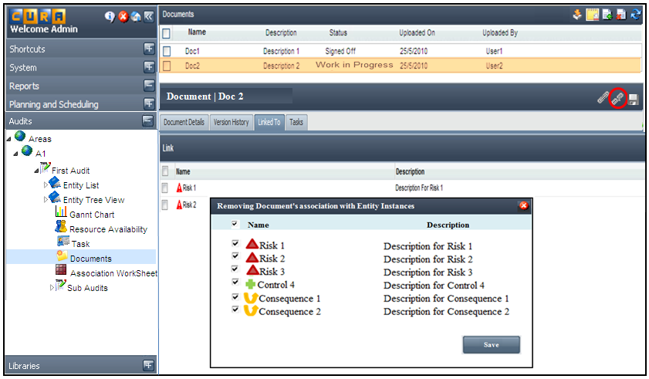
Figure 29 - Removing association between a document and the linked Entity Instances

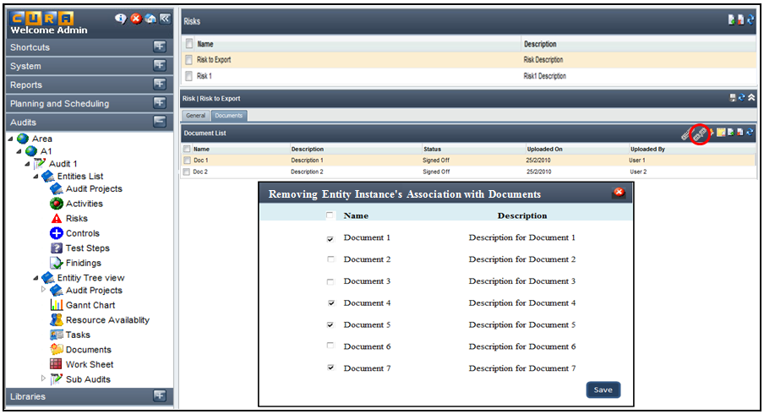
Figure 30 - Removing association between an Entity Instance and linked Documents

FR_DMS_13: Apply Permissions on Documents

Use Case Detail
Name | Apply Permissions on Documents
Summary | A document user needs to have appropriate permissions to perform various functions to manage the documents.  Permissions for managing documents are inherited from permissions defined for managing entities under the ‘Audit Entities’ and ‘Library Entities’ features.  However, there would be a feature called ‘Document Management’ under Audit with the permission type called ‘manage all’ which is used to maintain the Document repository.  Permissions are applied to ‘Roles’ available under the ‘System’ tab.  The different permission types required for Document Management and the actions that the permission types authorize are listed below.  - View – View document details, View Version details, Download document  - Create – Upload document, Check in document  - Update – Check in document, Check out document  - Delete – Delete current version of the document  - Review – Review the document, ask for rework  - Sign Off – Sign Off a document  - Unlock – Revert the document status from ‘Signed Off’ to any prior status, Override the ‘Check out’ of a document  - Manage All – Cumulative permissions – View, Create, Update, Delete and Review  The permissions defined on entities apply to the documents in the following way  Entity - Create = Document – Create  Entity – Update = Document – Update  Entity – View = Document – View  Entity – Delete = Document – Delete  Entity – Review = Document – Review  Entity – Signoff = Document – Signoff  Entity – Unlock = Document – Unlock
Actors | Document User
Preconditions | - User is logged on to Internal Audit  - User has selected the ‘System tab  - User has selected ‘Roles’  - User has selected a role for which permissions have to be assigned
Triggers | Selecting a role and clicking the ‘Permissions’ tab
Basic Flow | - User expands ‘System’ tab  - User selects ‘Roles’  - User selects a role  - User selects the ‘Permissions’ tab in the ‘Details’ section  - User selects the applicable permission types for the ‘Document Management’ feature  - Refer to the Permission Management FS – section 2.1 (Permission Management FS is attached in section 5.1)
Alternate Flow | NA
Post conditions | Permissions to manage documents will be applied to the selected role
Business Rules | - Permissions defined for managing entities are applicable to Document Management

Graphical User Interface
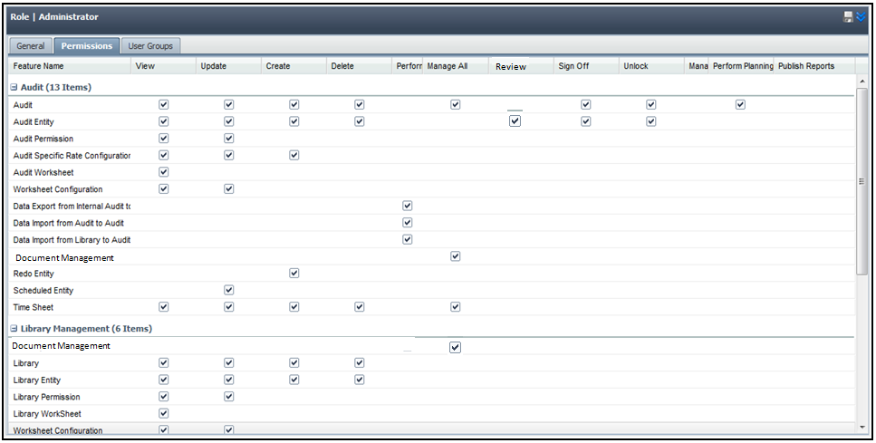
Figure 31 - Applying Document Management Permissions

